Attachment C – Locality Map
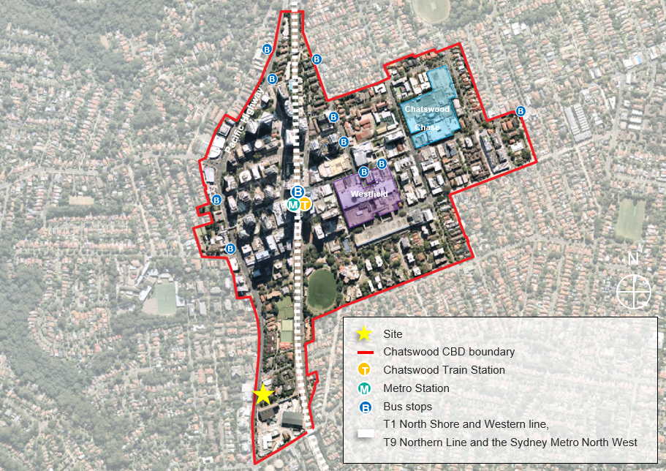
Figure 1: Site context map - expanded Chatswood CBD with the site located in the north (source: Nearmap, overlay by DPIE)

